

Floral Delivery

May 14, 2025  
To  
June 14, 2025

E-PROJECT  
**Developed using .NET Framework**

**Our website offers a seamless platform to order and deliver stunning flower bouquets for every occasion. We ensure fresh blooms, timely delivery, and a delightful experience for our customers.**

**Every Occasion Make Special With Us**

TERM & CONDITION

**1. Order Cancellation:  
 Orders can only be canceled within 2 hours of placement. After this period, cancellations or refunds are not permitted.**

**2. Delivery Policy:   
We deliver within specified areas and strive for on-time delivery. Delays due to unforeseen circumstances are not our responsibility.**

**3. Product Substitution:  
 In rare cases, if a specific flower or bouquet is unavailable, we may substitute it with a similar product of equal or higher value.**

**4. Payment Terms:   
All payments must be completed online at the time of placing the order. We ensure secure payment processing.**

**5 Customer Responsibility:  
 Accurate delivery details must be provided. We are not liable for failed deliveries due to incorrect information.**



Shop#27 Flower Market Sadar Karachi



info@onlinefloraldelivery.com



https://onlinefloraldelivery.com

TABLE OF CONTENTS

**S. No** **Pg. No**  
 **1. Introduction 4  
2. Website Synopsis 5  
3. Requirement Analysis 6  
4. Designing Project 7  
5. Data Flow Diagram 9  
6. Flow Chart 10  
7. Database Explanation 11  
8. Screen Shot of Website 12  
9. Source Code 14  
10. Payment Gateway Integration 16  
11. Admin Panel Features 16  
12. Testing & Quality Assurance 18  
13. User Guide 19  
14. Developer Guide 21**

INTRODUCTION

Welcome to our e-commerce platform, your one-stop destination for ordering and delivering exquisite flower bouquets for all occasions. Flowers have long been a timeless way to express emotions, celebrate milestones, and create memorable moments. Our platform is dedicated to helping you connect with loved ones, celebrate life's special events, and share joy through the beauty of fresh, professionally arranged flowers.

At our website, we offer a wide range of floral arrangements tailored for birthdays, weddings, anniversaries, and many other occasions. Each bouquet is crafted with precision and care, ensuring that it not only looks stunning but also conveys the emotions you want to express. Whether you're sending flowers to brighten someone's day or planning a grand event, we have options to suit every need and preference.

We pride ourselves on providing a user-friendly experience that allows customers to browse, personalize, and order bouquets with ease. With secure payment options and a robust delivery system, we ensure that your orders reach their destination on time and in perfect condition. Our goal is to bring convenience and happiness to your fingertips, making every celebration unforgettable.

Choose us for reliability, quality, and exceptional customer service. Let us be a part of your cherished moments and help you create lasting memories through the language of flowers.

.

WEBSITE SYNOPSIS

Our e-commerce website is a comprehensive platform designed for flower enthusiasts and gift-givers who seek convenience, quality, and reliability. The website caters to both individual customers and businesses, offering a wide range of floral arrangements and bouquets suitable for various occasions, including birthdays, weddings, anniversaries, and other celebrations.

The platform combines aesthetic design with functional features, ensuring a seamless user experience. Customers can easily browse through an extensive collection of bouquets, select their preferred arrangements, and personalize their orders with custom messages. The website includes secure payment options, a dynamic cart system, and a robust delivery mechanism to guarantee timely and efficient service.

Key features include:

* **Category-Based Browsing**: Users can explore bouquets sorted by occasions, price ranges, and preferences.
* **Custom Messaging Options**: The ability to choose predefined messages or write personalized notes enhances the gifting experience.
* **User Accounts**: Registered users can track orders, save favorite products, and manage their profiles.
* **Admin Dashboard**: Administrators can manage products, track orders, handle user accounts, and update inventory seamlessly.
* **Nationwide Delivery**: Leveraging a network of florists, the website ensures fresh and timely delivery across multiple locations

REQUIREMENT ANALYSIS

**1. Purpose and Objectives:**  
- Enable customers to browse and order flowers online with ease.  
- Provide real-time updates on flower availability and shipping status.  
- Offer a seamless and secure online payment experience.  
- Allow customers to create accounts and track order history.  
- Create an admin panel for managing products, orders, and user accounts.  
  
**2. Content Requirements:**  
  
- Comprehensive flower catalog with descriptions, prices, and images.  
- Easy-to-navigate product categories (e.g., bouquets, seasonal flowers, special offers).  
- Customer support, contact information, and feedback functionality.  
- Integration with popular payment gateways (e.g., PayPal, Stripe).  
  
**3. Design and User Experience:**  
  
- The website's design features a vibrant, floral theme that complements the product offerings.  
- Simple and intuitive navigation to make shopping easy for users.  
- A mobile-first, responsive layout to cater to customers browsing from various devices.

dESIGNING PROJECT

The design phase of the website focused on delivering a user-friendly, visually appealing, and functional interface.   
  
The project was built using the .NET framework, ensuring a robust back-end system and seamless front-end integration.  
  
**Key design elements include:**  
  
Clean and modern interface with easy navigation bars and filters for products.  
  
Use of high-quality product images to enhance visual appeal.  
  
Integrated search functionality for customers to find specific flowers quickly.  
  
A mobile-optimized design to ensure compatibility with smartphones and tablets.  
  
User-friendly checkout process with clear call-to-action buttons for smooth transactions.  
  
We prioritized the user experience, ensuring that customers could effortlessly browse, select, and purchase flowers.

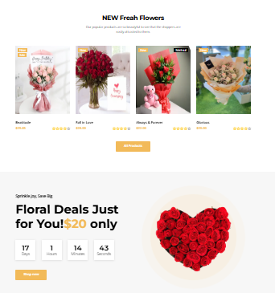

Data flow Diagram

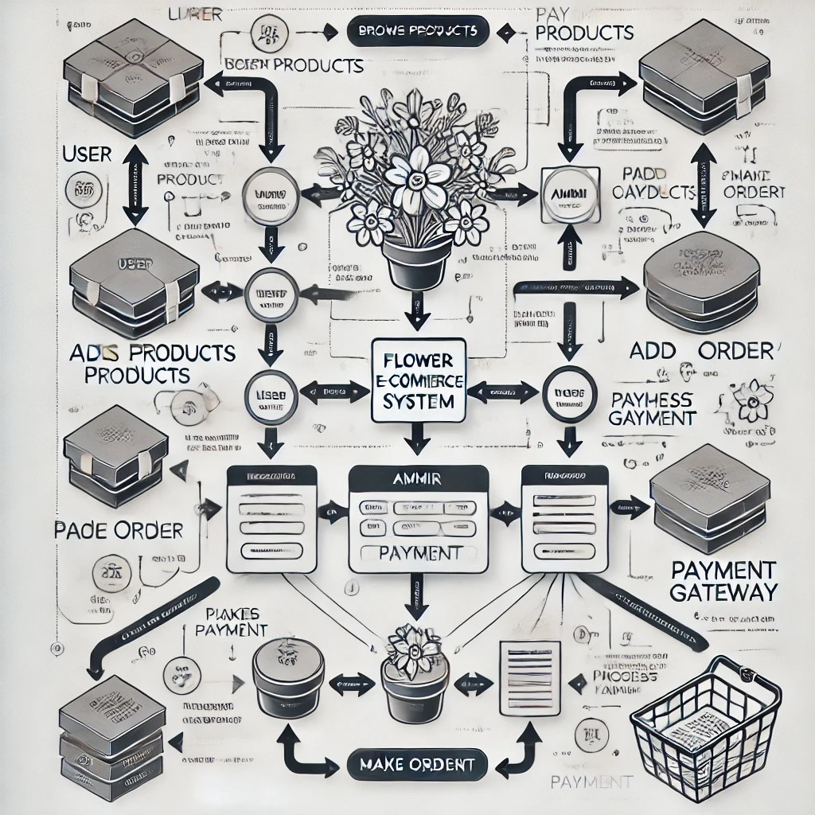The data flow in our flower e-commerce system begins with the User, who interacts with the website to browse products, place orders, and make payments. The admin is responsible for managing the products and orders in the system. Once an order is placed, the Payment Gateway processes the payment, and the order details are saved to the Database, which stores all information related to users, products, and orders. This flow ensures that data is efficiently managed and securely processed at every step, providing a smooth and reliable experience for both users and administrators.

flow chart

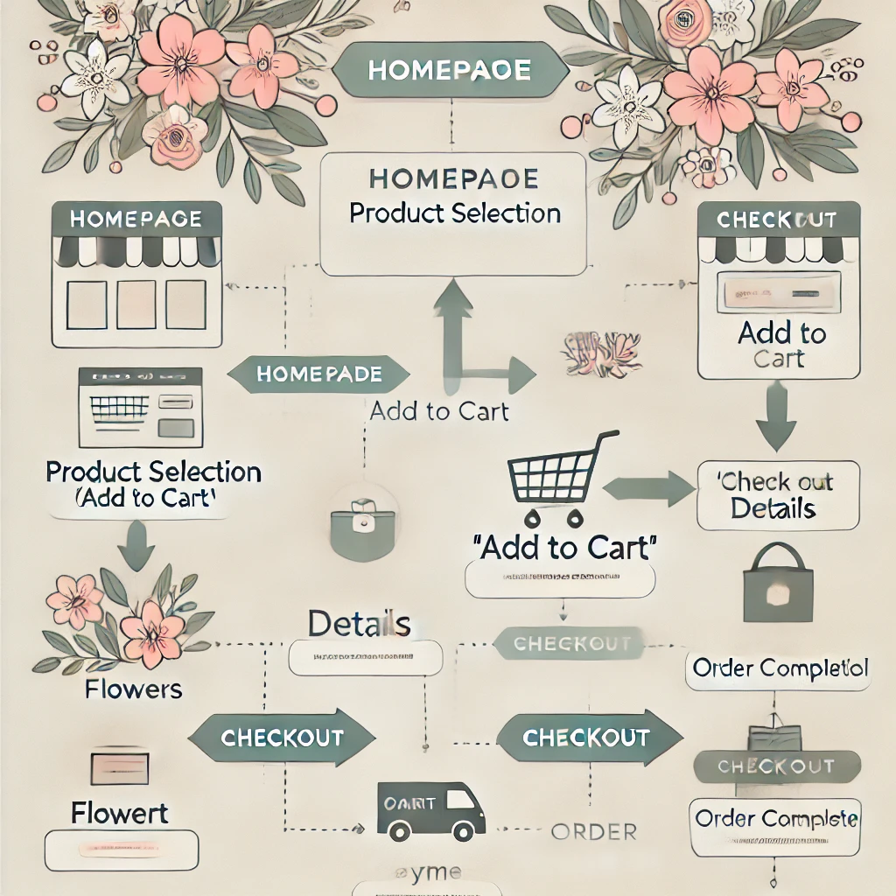

database explanation

The database diagram for the e-commerce flower website is designed to efficiently manage customer information, product details, orders, payments, and product categories. The **Customers** table stores information about the website's users, including their personal details, login credentials, and contact information. The **Products** table holds details of each flower and floral arrangement available for purchase, such as the product's name, description, price, and stock quantity. To categorize products, the **Categories** table groups flowers into categories like bouquets, seasonal flowers, or special offers.

The **Orders** table records customer orders, including the order date, shipping address, and total amount, linking to the **Customers** table through the **customer_id** field. Each order can contain multiple products, which are stored in the **OrderDetails** table. This table connects the **Orders** and **Products** tables, allowing multiple products to be linked to a single order, with the quantity and price for each product recorded.

The **Payments** table tracks the payment information for each order, including the payment method, status, and transaction details. This table is linked to the **Orders** table, ensuring each order has an associated payment record.

The relationships between these tables ensure smooth operations, enabling functionalities such as order tracking, payment processing, and customer management. **Foreign keys** in the diagram establish relationships, such as linking orders to customers and products, ensuring referential integrity and simplifying queries for order history, product availability, and customer data.

screenshot of website

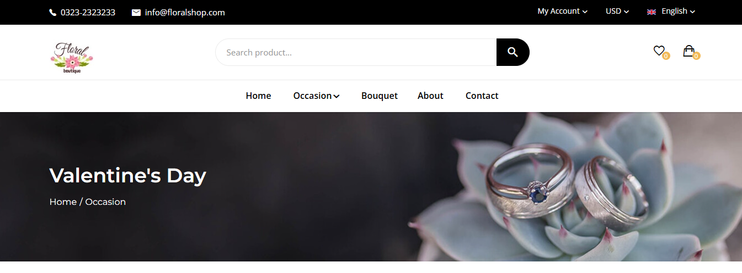

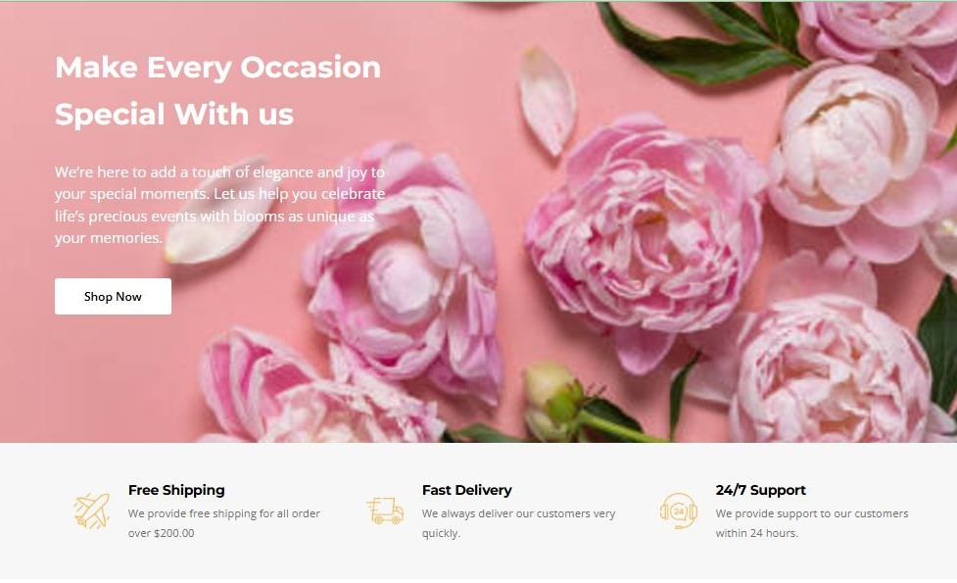

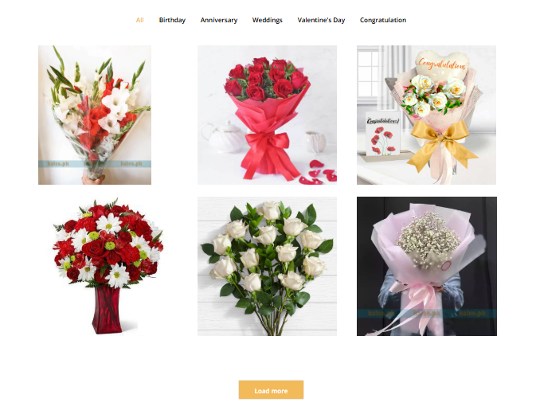

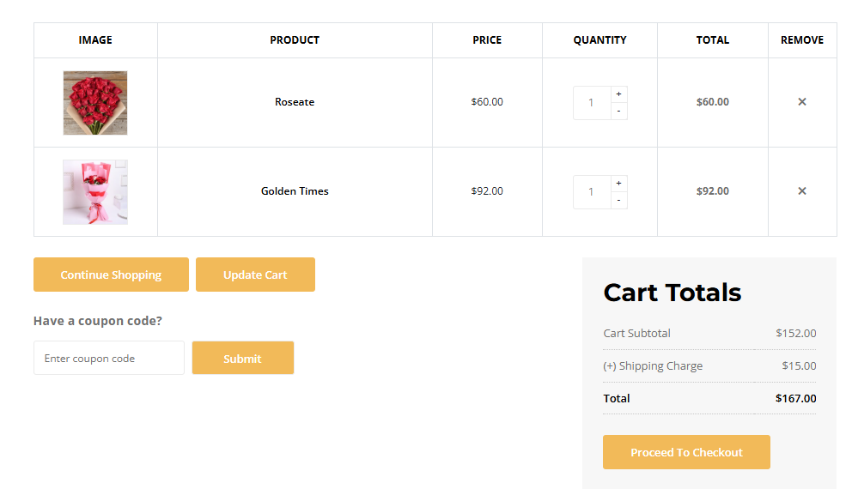

source code

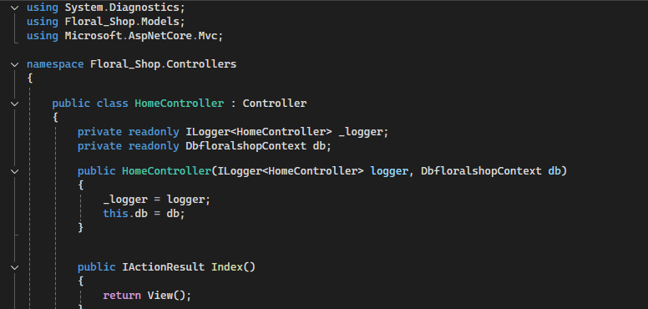

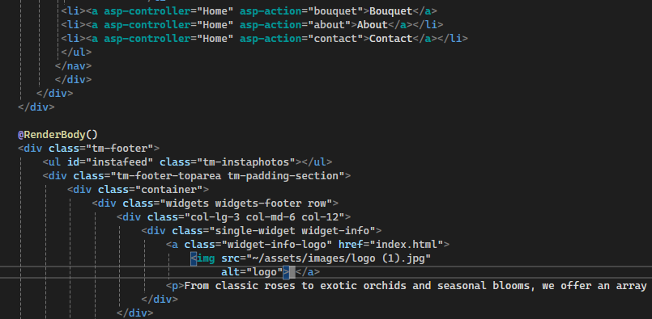

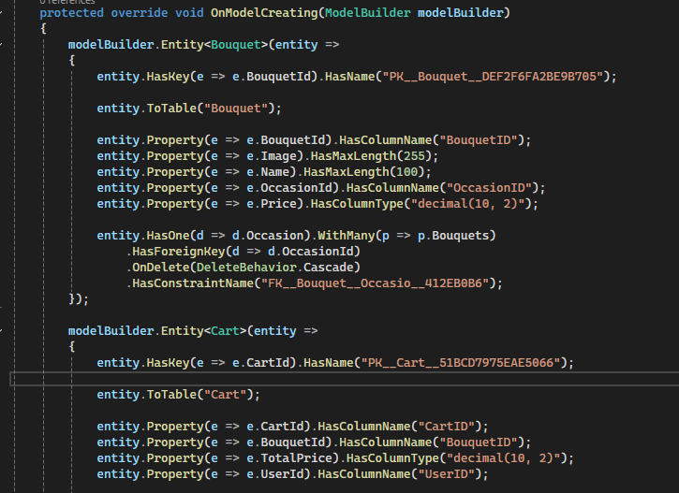

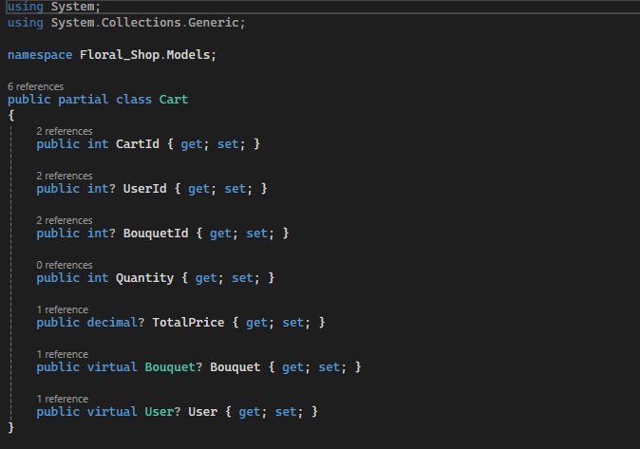

payment getway integration

The **Payment Gateway Integration** on the floral shop website ensures that customers can securely complete their transactions online. By integrating popular payment gateways like **PayPal** and **Stripe**, the website offers a seamless and reliable method for processing payments. Customers can choose from various payment options, such as credit/debit cards or PayPal, to complete their purchases. The payment gateway encrypts sensitive information, such as credit card numbers and billing addresses, ensuring secure data transmission and protecting customer privacy. Additionally, the integration provides real-time transaction feedback, informing customers about payment success or failure. The payment system is designed to be fast, user-friendly, and reliable, giving customers confidence in their online purchases while ensuring smooth order for administrators. This secure and efficient payment process is vital to the overall shopping experience, enhancing trust and facilitating a seamless checkout process on the platform.

admin panel feature

The **Admin Panel** of the e-commerce flower website is designed to provide administrators with a comprehensive and easy-to-use interface for managing key aspects of the online store. It offers robust features that enable efficient control over products, orders, customer data, and website settings. The core features of the Admin Panel include:

**1.** **Product Management**: Administrators can easily add, update, or delete products in the catalog, including details like product names, descriptions, prices, stock quantities, and images. Additionally, they can categorize products into various flower types and collections, such as bouquets, seasonal flowers, and special offers.

**2.** **Order Management**: The admin panel allows administrators to view and manage customer orders. They can track the status of each order, from order placement to shipping and delivery. Administrators can also update order statuses and process refunds if needed.

**3.** **Customer Management**: Administrators can view and manage customer accounts, including accessing customer details, order history, and contact information. They have the ability to support customer queries, manage feedback, and handle any issues related to user accounts.

**4.** **Inventory Management**: Admins can monitor product stock levels in real-time, receive notifications for low-stock products, and update inventory as needed. This feature ensures that the website displays accurate product availability, reducing the risk of overselling.

**5.** **Payment and Transaction Management**: Admins have access to payment details for all completed orders, including transaction history, payment methods, and payment statuses. This feature helps ensure the accuracy of financial records and facilitates dispute resolution or refunds.

**6.** **Reporting and Analytics**: The admin panel provides reports and analytics on sales performance, order history, customer trends, and inventory levels.

Testing & Quality Assurance

The **Testing & Quality Assurance (QA)** process for the e-commerce flower website is essential to ensure a seamless and reliable user experience. This includes **unit testing** to verify individual components like the shopping cart and payment system **Integration Testing**: After individual components are tested, integration testing ensures that all the system’s modules work together seamlessly. For example, it verifies that the payment gateway interacts correctly with the order management system, and that product updates in the admin panel reflect on the website in real-time., and **user acceptance testing (UAT)** to validate the website meets end-user expectations. The site undergoes **performance testing** to handle high traffic and **security testing** is a top priority, and the website is rigorously tested to identify vulnerabilities that could be exploited by malicious users. Penetration testing, encryption testing, and secure payment processing are all critical to ensure customer data and financial transactions are protected., **cross-browser and cross-device testing** ensures compatibility across platforms, while **regression testing** ensures new features don’t disrupt existing functionality. **Usability testing** focuses on the overall user experience (UX) to ensure the website is intuitive and easy to navigate. It involves gathering feedback from real users to identify pain points in the user interface and improve the site’s design for ease of use.

user Guide

**User Guide** for the e-commerce flower website. This guide will provide you with all the necessary information to navigate the website, browse products, make purchases, and manage your account. Whether you're a first-time visitor or a returning customer, this guide will help you make the most of your online shopping experience.

**1. Getting Started**

* **Accessing the Website**: Open your web browser and enter the URL of the website. The homepage will display a welcoming design with easy navigation to explore flowers, special offers, and more.
* **Supported Devices and Browsers**: The website is designed to be responsive, working seamlessly across all devices, including desktops, tablets, and smartphones. It supports major browsers like Google Chrome, Mozilla Firefox, Safari, and Microsoft Edge.

**2. Browsing the Website**

* **Catalog Navigation**: On the homepage, you can view various categories like "Bouquets", "Seasonal Flowers", and "Special Offers". Use the navigation menu or search bar to find specific flower arrangements or products.
* **Product Details**: Click on any product to view detailed information, including the product name, description, price, availability, and high-quality images.
* **Filters**: Use available filters to narrow down your search based on price, flower type, or occasion.

**3. Adding Items to the Cart**

* **Add to Cart**: Once you find a product you want to purchase, select the quantity and click the "Add to Cart" button. The item will be added to your shopping cart.
* **View Cart**: To view or modify your cart, click on the cart icon in the top-right corner of the website. Here, you can adjust quantities, remove items, or proceed to checkout.

**4. Checkout and Payment**

* **Proceed to Checkout**: When you're ready to complete your purchase, click on "Proceed to Checkout" in your cart. You will be prompted to log in or create an account if you haven't already.
* **Enter Shipping Information**: Provide your shipping address where the order will be delivered.
* **Choose Payment Method**: Select your preferred payment method, such as credit/debit card or PayPal, and enter the necessary payment details.
* **Review and Confirm**: Double-check your order details, including products, shipping address, and total amount. Once everything looks correct, click on "Confirm Order" to complete your purchase.

**5. Order Confirmation and Tracking**

* **Order Confirmation**: After your payment is processed, you will receive an order confirmation email with your order details.
* **Track Your Order**: You can track your order status by logging into your account and navigating to the "Order History" section.

developer Guide

This **Developer Guide** for the e-commerce flower website. This guide provides the necessary information to set up, understand, and contribute to the development of the website. Whether you are a new developer joining the project or need to understand the existing codebase, this guide will help you navigate through the setup, structure, and core components of the system.

**1. Prerequisites**

Ensure you have the following installed:

* **.NET Framework (version 8.0 or higher)**
* **Visual Studio**
* **SQL Server** for the database
* **Git** for version control

**2. Setting Up the Project**

1. **Clone the Repository** using Git.
2. **Open the Solution File (.sln)** in Visual Studio.
3. **Set Up the Database** using SQL scripts or manually create the database.
4. **Build and Run the Project** in Visual Studio by pressing **F5**.

**3. Understanding the Codebase**

The project consists of:

* **Frontend**: Built using HTML, CSS, and JavaScript, with **Bootstrap** for responsive design.
* **Backend**: Developed in **ASP.NET Core**, handling business logic through controllers and services.
* **Database**: SQL Server-based, with models like Product, Order, Customer, and Payment.
* **Views**: Razor Views to render dynamic pages.

**4. Contributing**

1. **Fork the Repository** and create a new branch.
2. **Make Changes** following coding best practices.
3. **Test the Changes** by running unit tests and manual testing.
4. **Commit and Push** the changes to your branch.
5. **Create a Pull Request** for review and merging.

**5. Testing and Debugging**

* Run unit tests and use Visual Studio's debugging tools to troubleshoot any issues.

thank you

**Thank you for taking the time to read through this documentation. We hope it has provided you with a clear understanding of how the e-commerce flower website operates and the features it offers. Your feedback is always welcome and helps us improve the user experience and functionality of the platform.  
  
If you have any questions or suggestions, please don't hesitate to reach out. We value your support and are excited to continue improving and expanding the website for your benefit.**

**Thank you again, and happy browsing!**